Operational Concept Description (OCD)

LOSE4GOOD.org Database Driven Socially Connected Website

Team 08

Team Member Name | Primary Role | Secondary Role
Ali Alotaibi | Requirements Engineer | System Architect
Ankit Kalwar | Operational Concept Engineer | Project Manager
Arul Samuel | System Architect | Requirements Engineer
Manas Jog | Prototyper | Requirements Engineer
Monil Ashok Parikh | Quality Focal Point | System Architect
Omkar Yerunkar | Project Manager | Feasibility Analyst
Shalini Srinivas | Feasibility Analyst | Life cycle planner

12/01/2013

Version History
Date | Author | Version | Changes made | Rationale
09/26/13 | SS | 1.0 | - Original for CSCI577a: Tailored from ICSM OCD Template | - Initial Document for Evaluation Phase
09/27/13 | AK | 1.0 | - System Boundary Diagram added | - To fit CS577a VC Package
10/16/13 | AK | 2.0 | - Completion of remaining sections | - To fit CS577a FC Package
10/23/13 | AK | 2.1 | - Updated some sections | - Based on FCR ARB feedback.
12/01/13 | AK | 3.0 | - Updated sections based on feedback | - To fit CS577a DC Package

Table of Contents
Operational Concept Description (OCD) i
Version History ii
Table of Contents iii
Table of Tables iv
Table of Figures v
1. Introduction 1
2. Shared Vision 2
2.1 Overview of the system 2
2.2 System Boundary and Environment 4
3. System Transformation 5
3.1 Information on Current System 5
3.2 System Objectives, Constraints and Priorities 5
3.3 Proposed New Operational Concept 7
3.4 Organizational and Operational Implications 9

Table of Tables
Table 1: The Program Model 2
Table 2: Level of Service Goals 5
Table 3: Relation to Current System 6

Table of Figures
Figure 1: Benefits Chain Diagram 4
Figure 2: System Boundary and Environment Diagram 4
Figure 3 : Element Relationship Diagram 7
Figure 4 : Business Workflows Diagram 8

Introduction
The purpose of OCD is to provide a detailed early operational concept in order to achieve the shared vision of the success-critical stakeholders of lose4good.org – Database Driven Socially Connected Website.

The success-critical stakeholders for this project lose4good.org:
- Paul Charron , Client /Project owner
- Users, people who want to lose weight using our website as a motivation.
- Sponsors, who want to sponsor users so as to motivate them to lose weight
- Charity organizations, to whom all the money pledged by sponsors is donated.
- Advertisers, who would like to promote offers/services or their brand using our website.
- Team 08, who will be involved in developing of the project.

This document is an initial reference for benefits expectation, benefits chain, current system and environment assessment, system objectives, constrains and priorities, new operational concept, organizational and operational implications.

The status of the OCD is currently at the Foundations Commitment Package version number 3.0.

Shared Vision

Overview of the system
We are an online tool that bridges peoples’ healthy goals to motivation through the use of community and charity by recognizing that each one contributes a unique piece to the success of the other.
In order to understand or know what projects or related initiatives are required for program management we create a Program Model as shown below. The model helps in designing and managing programs. Understanding the concept of a program – how it is different from traditional projects and what it brings to them – is the first major step to embarking on the route to effective, proactive benefits management. The Program Model starts out as shown in the table below
Table 1: The Program Model
Assumptions:
- Families and businesses are willing to sponsor individuals for losing weight.
- Individuals are motivated by sponsorships and charities to lose weight.
- Charities are willing to associate themselves with weight-loss individuals and lose4good.

Stakeholders | Initiatives | Value Propositions | Beneficiaries
- Client  - Developers  - Marketing team  - Charity Organization  - Sponsors  - Maintainers | - Develop System  - Form relationships with charities and business sponsors  - Create a marketing campaign  - Design reward program | - Enable people to get sponsorship for their weight loss goals  - Increase motivation for people trying to lose weight  - Improve advertisement opportunities for the sponsors. | - Weight loser  - Charity Organization  - Sponsors  - Society
Cost |  | Benefits
- Development cost  - Online space cost to host the website  - Transaction fee required to get money from sponsors and send to charity  - Marketing cost  - Maintenance cost |  | - Increase number of weight losers  - Increase user donations and advertisements.  - Decrease manual data monitoring efforts.  - Increase ease of payment through online transaction.

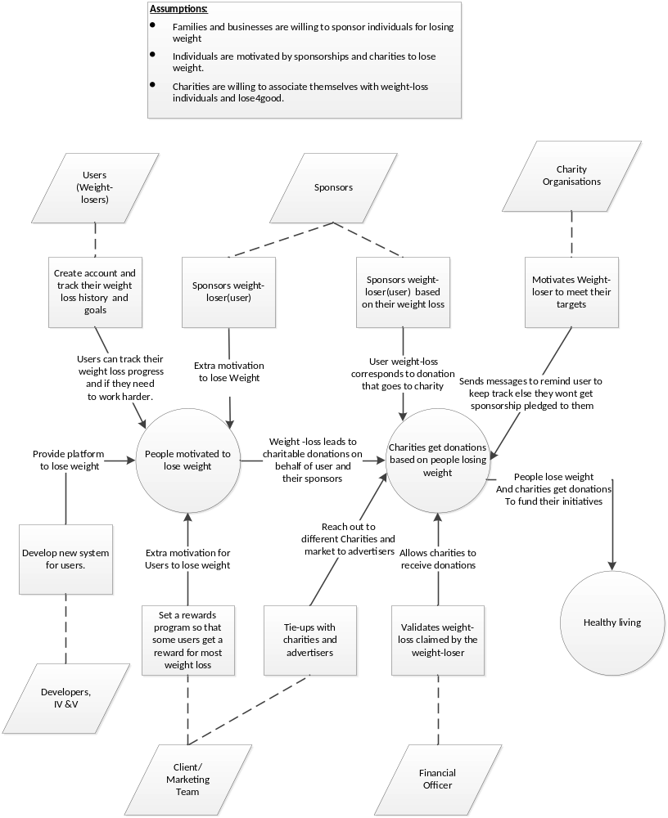

Figure 1: Benefits Chain Diagram

System Boundary and Environment
The system boundary and environment diagram contains a list of services and functions that the project team will be responsible for developing and delivering, as well as the system environment showing the stakeholders' organizations and other systems for which the project has no authority or responsibility, but with which the delivered system must interface in order to deliver the desired benefits. The figure below shows the system boundary and environment diagram.

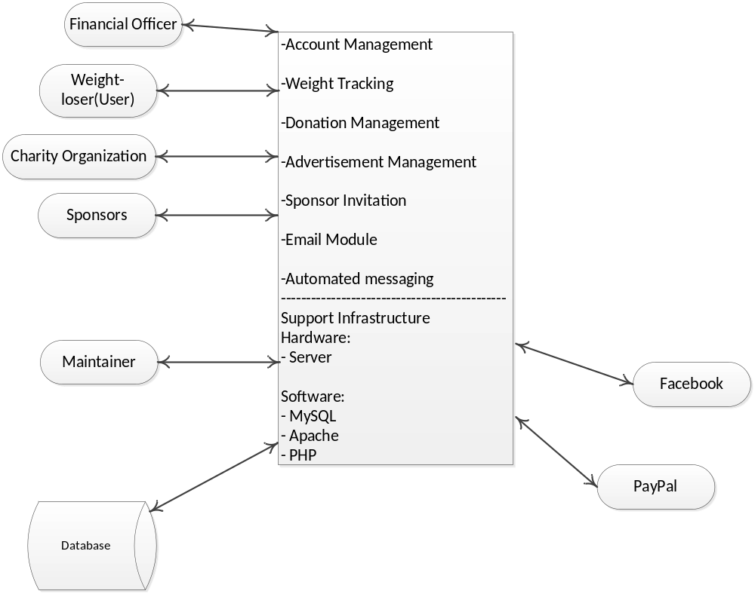
Figure 2: System Boundary and Environment Diagram

System Transformation

Information on Current System
The system is being developed from ground up. Hence, information about current system cannot be mentioned in this case.

System Objectives, Constraints and Priorities

Capability Goals
Capability Goals | Priority Level
OC-1: Create and track weight loss goals | Must Have
OC-2: Account management | Must Have
OC-3: Donation Management | Must Have
OC-4: Sponsor invitation | Must Have
OC-5: Ability to advertise products and services | Would Like
OC-6: Login using Facebook | Must Have
OC-7: Discussion Forum | Would Like
OC-8: Reward management | Would Like

Level of Service Goals
Table 2: Level of Service Goals
Level of Service Goals | Priority Level | Referred WinWin Agreements
LOS-1: Payment Ease: The payment system will support monetary transactions in U.S. and Canada. | Should have | WC_2751
LOS-2: Uptime: The system will use a database that has 99.5% uptime (guaranteed by Heroku). | Should have | WC_2749
LOS-3: Compatibility: The system will Support the following browsers: IE 8+, Chrome 25+, Mozilla Firefox 16+ and Safari 6+ | Should Have | WC_2748

Organizational Goals
OG-: Motivate people to lose weight.
OG-2: Make charitable donations
OG-3: Promote healthy living.

Constraints
CO-1: Minimum Monetary Budget: The selected NDI/NCS should be free or of minimum cost as this is a not-for profit initiative

Relation to Current System
Table 3: Relation to Current System
Capabilities | Current System | New System
Roles and Responsibilities | The Current System does not have any roles and responsibilities | The new system will have a maintenance team responsible for keeping the site up and financial officer to verify donations.
User Interactions | The Current System does not have any user interaction | The new system will interact with weight loser, sponsors, advertisers and charities
Infrastructure | No infrastructure | Website will be hosted on a cloud server accessible anywhere in the world.
Stakeholder Essentials and Amenities | No stakeholders | The system will be used by weight losers, sponsors, advertisers and charities that can access the system from anywhere
Future Capabilities | NA | The new system can be used by weight losers as a means of tracking their weight loss, keep themselves motivated.

Proposed New Operational Concept

Element Relationship Diagram

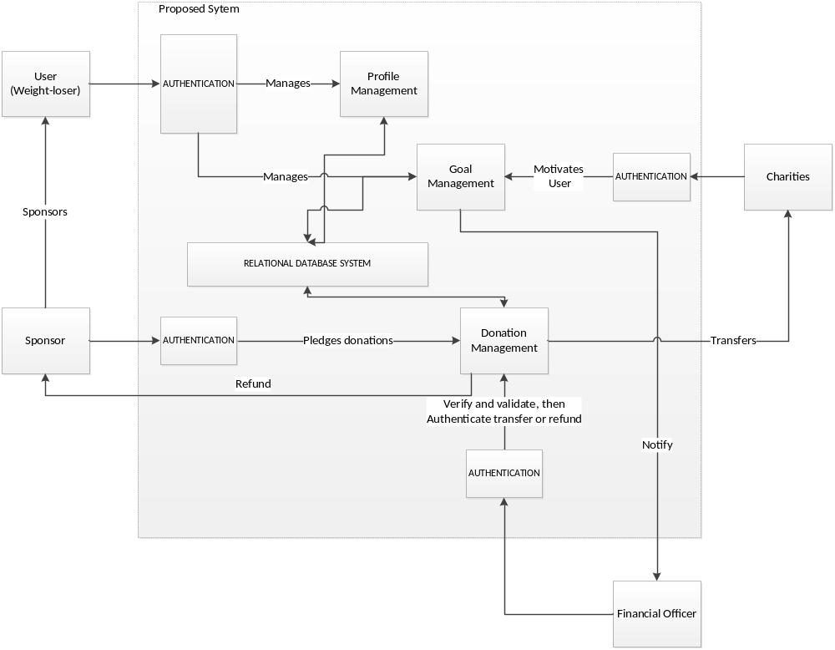
Figure 3 : Element Relationship Diagram

Business Workflows
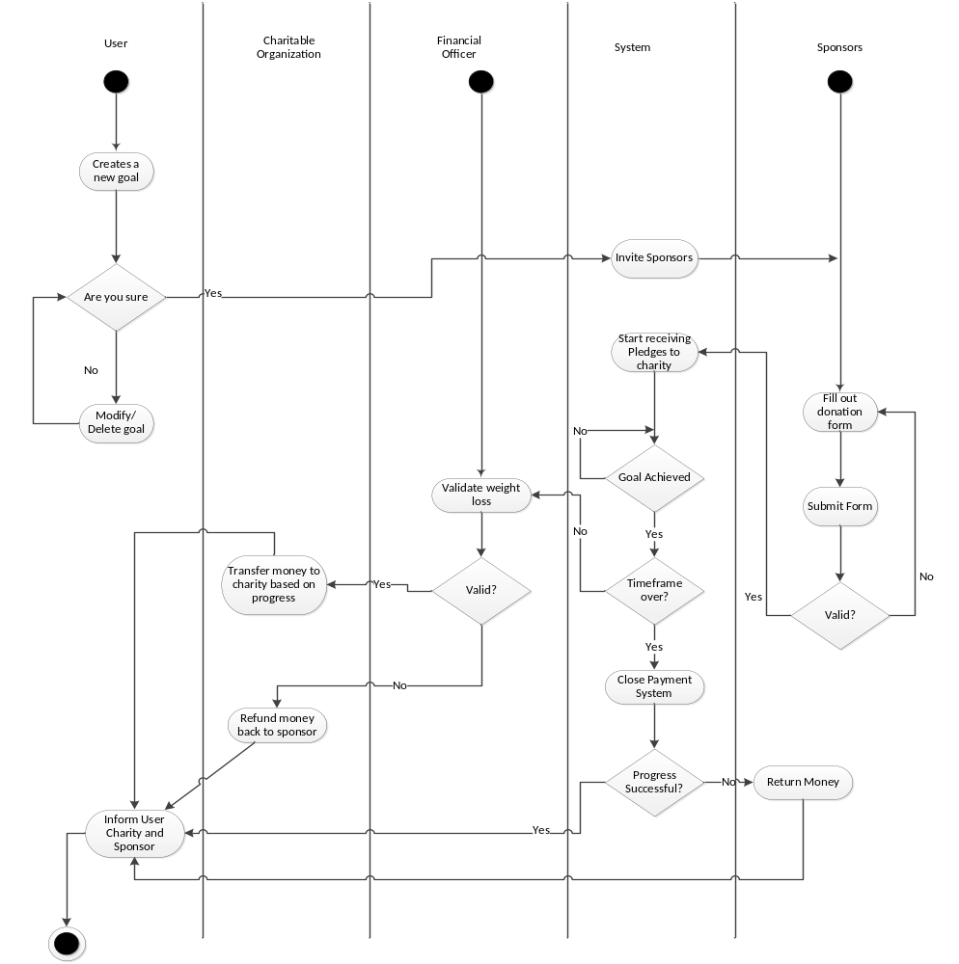
Figure 4 : Business Workflows Diagram

Organizational and Operational Implications

Organizational Transformations
- The need to hire a new system maintainer to take care of the system, a new database manager to maintain the new database.
- The discussion board will need to be moderated and hence need to hire moderators.
- The need to hire a marketing and sales team to pitch this to potential weight-losers and for tie-ups with charities and sponsors.
- The need to hire a financial officer to validate donations.
- The need to tie-up with health clubs to validate weight-losers weight-loss claims.

Operational Transformations
- Lose4good will become a new destination to keep weight-losers motivated in their quest to become healthy.
- Members will have benefit of discussion forum to communicate with other weight-losers and learn from others.
- Lose4good will become first of many 4good future initiatives.

